Rose to Carmen
Project IT Spec Handoff and Go-Live Onboarding
FranchiseIntelligenceOS
Version: 2026-07-06-franchiseos-clean-main-v1
Prepared by Rose — July 6, 2026
STATUS: Clean handoff to Carmen — NOT live approval. This GitHub push is not approval to go live, redesign, change features, or connect production data or live services.

1. Project Overview
FranchiseIntelligenceOS is an AI-powered franchise operations platform. It tracks franchise locations, licenses, compliance scores, tasks, audits, and documents, and includes an AI assistant that answers questions from live portfolio data plus an expansion-readiness view by US state.
- Dashboard: portfolio KPIs (including a Risk Alerts KPI) and a recent activity feed
- Locations: full CRUD with detail view (per-location licenses, checks, audits, documents)
- Compliance: 0–100 scoring with charts (status pie, avg-score bar, trend area, risk heatmap)
- Tasks: todo / in-progress / done, with auto-created remediation tasks from failed compliance checks
- Expansion: computed readiness score and recommendation per US state
- Documents: searchable SOP/policy/note library with real file uploads to object storage
- AI Assistant: multi-conversation chat grounded in live database data with citations
- Realtime notifications: socket.io alert bell (license expiring, task overdue)
- Marketing landing page (signed-out visitors) with an embedded ~81-second narrated product demo video

2. GitHub Repo, Branch, Commit Hash, and Version ID
Repository: https://github.com/contractorcomplianceco-cmyk/franchiseos.git
Branch: main
Version ID: 2026-07-06-franchiseos-clean-main-v1
Commit hash: To be recorded at push time. At the time this document was generated, local HEAD was 67794f86c4c5adf36348703d094e04381e2f3cc2. Because this document and final checkpoints are committed after generation, Rose must run “git rev-parse HEAD” in the Replit Shell immediately after pushing and send Carmen that hash. Carmen verifies her clone matches it.
Note: at generation time the local main branch was 6 commits ahead of GitHub origin/main. The push (performed by Rose via the Replit Git panel) brings GitHub main up to the newest clean version. This is a normal update push confirmed by Rose — no history rewrite.

3. Source Project URL
The source of truth is Rose's Replit workspace for the FranchiseIntelligenceOS project (accessible from Rose's Replit account). The GitHub repository above is the mirror used for handoff.

4. Temporarily Published Latest-Version Link
Published link (reviewed for visual confirmation): https://franchise-intelligence.replit.app/
This is a Replit deployment (.replit.app domain). It reflects the deployed state at its last publish; the GitHub push may include newer commits than the last deploy (documentation and internal type-safety fixes only — no visible design or feature differences).

5. Intended Endpoint Domain
Intended endpoint domain: demo.ccafranchiseintelligence.com
Endpoint classification: DEMO endpoint (not production)
This domain is not yet connected. Carmen prepares DNS/SSL for this domain as part of technical wiring. Rose must separately approve any production launch.

6. Visual Confirmation Screenshots
Captured July 6, 2026 from the published link https://franchise-intelligence.replit.app/:
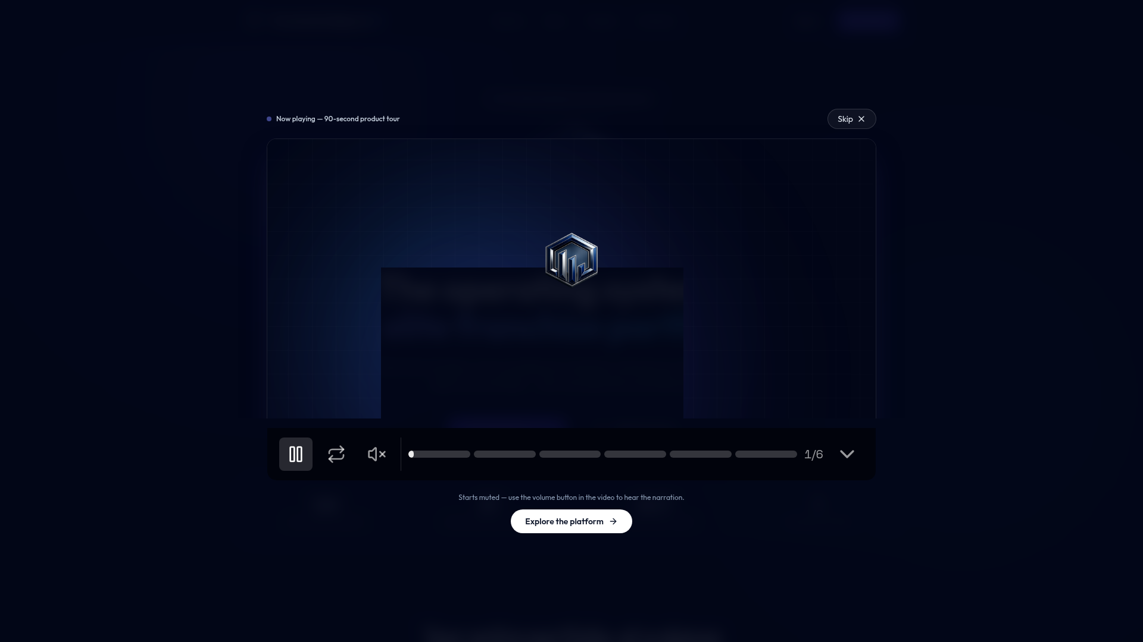
Home / first screen (published app, signed-out): landing page with autoplay product-tour overlay
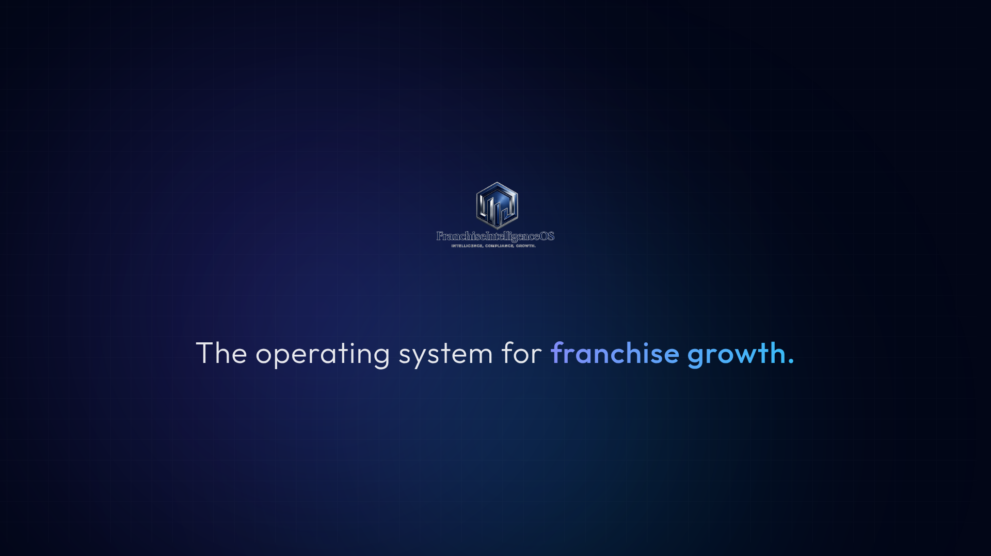
Public demo video page (/demo/): opening scene of the narrated product tour
Authenticated screens (dashboard and modules) sit behind Clerk sign-in and could not be screenshotted from the public link. Instead, an automated read-only browser verification was run against the app on July 6, 2026: it signed in via Clerk, and confirmed the Dashboard (KPI cards), Compliance (charts), and Tasks pages all render correctly with data. Carmen can visually verify these screens after her first sign-in.
The visible version matches the intended clean newest version. No mismatch was found.

7. What Was Pushed
- Full clean source tree of the pnpm monorepo:
  - artifacts/franchise-os — React + Vite frontend (all pages, components, hooks)
  - artifacts/api-server — Express 5 API server (all routes, auth middleware, realtime, storage)
  - artifacts/demo — video-js marketing demo video (source + audio assets)
  - artifacts/mockup-sandbox — internal component preview sandbox (development tool only)
  - lib/ — shared libraries: db (Drizzle schemas), api-spec (OpenAPI + codegen), object-storage-web, integrations-openai-ai-server, and related packages
  - Public/static assets required by the app (logos, demo audio, generated images)
  - Config files: pnpm-workspace.yaml, tsconfigs, package manifests, pnpm-lock.yaml, .gitignore
  - Docs: replit.md, HANDOFF.md, Rose-Handoff.md, CURSOR-HANDOFF.md, and this document

8. What Was Intentionally Excluded
- node_modules (dependency folders)
- Build outputs (dist, out-tsc, *.tsbuildinfo) and caches
- .env files and all secret values (none were ever committed — verified: no .env files tracked in git)
- Local databases and database contents (data lives in the managed PostgreSQL service, not in the repo)
- Old exports, stale prototypes, or previous app leftovers (none present — repo history is a single clean lineage)
- Test artifacts and temporary files
.gitignore was verified to protect dependencies, build outputs, caches, and local-only files.

9. Build / Start Commands
pnpm install # install all workspace dependencies
pnpm run typecheck # full typecheck across all packages (passes clean)
pnpm run build # typecheck + build all packages
pnpm --filter @workspace/api-server run dev # run the API server (port 8080, served under /api)
pnpm --filter @workspace/franchise-os run dev # run the frontend dev server
pnpm --filter @workspace/api-spec run codegen # regenerate API hooks/schemas from OpenAPI spec
pnpm --filter @workspace/db run push # push DB schema changes (development only)
Note: the demo video artifact's vite build reads PORT (and BASE_PATH) environment variables at config-load time. A build error mentioning PORT is an environment configuration issue, not a code bug.

10. Framework, Package Manager, and Runtime Versions
- Runtime: Node.js v24.13.0
- Package manager: pnpm 10.26.1 (pnpm workspaces monorepo — npm/yarn must not be used)
- Language: TypeScript 5.9 (strict)
- Frontend: React 18 + Vite, wouter (routing), TanStack Query, shadcn/ui + Tailwind, recharts, framer-motion
- Backend: Express 5, socket.io (realtime), Drizzle ORM
- Database: PostgreSQL
- Validation/API contract: Zod v4, OpenAPI spec (lib/api-spec/openapi.yaml) with Orval codegen

11. Required Environment Variables (values redacted)
All values are REDACTED. Carmen provisions her own values per environment. Names only:
- DATABASE_URL — PostgreSQL connection string [REDACTED]
- PORT — server port (workflow/deployment provided) [REDACTED]
- NODE_ENV — environment name [REDACTED]
- LOG_LEVEL — API server log verbosity [REDACTED]
- CLERK_SECRET_KEY — Clerk server key [REDACTED]
- CLERK_PUBLISHABLE_KEY / VITE_CLERK_PUBLISHABLE_KEY — Clerk client keys [REDACTED]
- VITE_CLERK_PROXY_URL — Clerk proxy URL for the frontend [REDACTED]
- AI_INTEGRATIONS_OPENAI_BASE_URL — OpenAI-compatible endpoint (Replit AI integration proxy) [REDACTED]
- AI_INTEGRATIONS_OPENAI_API_KEY — key for the above [REDACTED]
- DEFAULT_OBJECT_STORAGE_BUCKET_ID — object storage bucket [REDACTED]
- PRIVATE_OBJECT_DIR — private objects prefix [REDACTED]
- PUBLIC_OBJECT_SEARCH_PATHS — public asset search paths [REDACTED]
- SESSION_SECRET — session signing secret [REDACTED]
No secret values are committed to the repository. Verified: git tracks no .env files.

12. Auth Status
- Provider: Clerk (Replit-managed whitelabel tenant). Fully working in the current deployment: sign-up, sign-in, sessions.
- Roles: admin / manager / user. The FIRST user ever to sign up automatically becomes admin (race-safe).
- Server-side enforcement: all /api routes except /api/healthz require auth; DELETE requires admin; POST/PUT/PATCH require manager or admin; AI chat open to all authenticated users.
- IMPORTANT: the Clerk tenant and its keys are provisioned by Replit and tied to Replit hosting. If the app moves off Replit, Carmen must create an independent Clerk application (or equivalent) and swap the keys/proxy URL.

13. Database / Storage Status
- Database: Replit-managed PostgreSQL, live and in use by the published app. Schema managed by Drizzle ORM (lib/db/src/schema/): locations, licenses, complianceChecks, tasks, audits, documents, conversations, messages, users.
- Current database CONTENTS are sample/demo portfolio data, not real customer data.
- File storage: Replit App (object) Storage, live — real uploads via presigned URLs (Uppy on the client), served through /api/storage with ACL checks.
- If hosting moves off Replit: Carmen must provision her own PostgreSQL and an object-storage bucket (GCS/S3) and update the env vars; the storage helper code targets Google Cloud Storage-style presigned URLs.

14. API / Integration Status
- Internal API: Express server mounted under /api; contract-first from lib/api-spec/openapi.yaml; Zod-validated requests/responses; React Query hooks generated by Orval.
- Realtime: socket.io on the same server, authenticated via Clerk cookies; pushes license-expiring and task-overdue alerts on mutation plus a 60-second interval.
- No third-party business integrations (no CRM, no external franchise systems) are wired.

15. Email / SMS / Payment / AI Status
- Email: NOT implemented. No email service is wired.
- SMS: NOT implemented. No SMS service is wired.
- Payments: NOT implemented. No payment provider is wired.
- AI: LIVE. The AI assistant calls an OpenAI-compatible endpoint through Replit's AI-integration proxy (auto-provisioned env vars). Off Replit, Carmen must supply a direct OpenAI API key and update AI_INTEGRATIONS_OPENAI_BASE_URL / _API_KEY.

16. What Is Real vs Simulated / Demo / Sample
- REAL (fully functional code paths): authentication, roles, all CRUD (locations, licenses, checks, tasks, audits, documents), compliance scoring, auto-created remediation tasks, expansion readiness computation, AI chat with citations, file uploads to object storage, realtime notifications.
- SAMPLE/DEMO: the DATA currently in the database is sample franchise portfolio data for demonstration. No real client data exists in the system.
- MARKETING: the landing page and the /demo video are marketing content; the video's dashboard scenes are stylized recreations, not live UI.
- There are no mocked API endpoints and no simulated features — every feature operates against the real database.

17. What Still Needs to Be Wired
- Custom domain demo.ccafranchiseintelligence.com (DNS + SSL) — not yet connected.
- Email/SMS notifications — none exist; wire only if Rose requests the feature (feature change requires Rose's approval).
- Admin role management UI — role changes are currently done by direct database update.
- If migrating off Replit hosting: independent Clerk app, PostgreSQL instance, object-storage bucket, and OpenAI key (see sections 12, 13, 15).

18. What Needs to Be Connected and How
- Option A — stay on Replit hosting (fastest): in the Replit deployment settings, add the custom domain demo.ccafranchiseintelligence.com and create the DNS records it shows (CNAME/A + TXT) at the DNS provider. SSL is automatic. All services (DB, storage, Clerk, AI) keep working unchanged.
- Option B — external hosting (e.g. AWS): provision Node 24 + pnpm; provision PostgreSQL and run the Drizzle schema push; create a storage bucket and set the three storage env vars; create a Clerk application and set the four Clerk vars; obtain an OpenAI API key and set the two AI vars; build with pnpm run build; serve API and static frontend behind one origin so /api routing works; point DNS for demo.ccafranchiseintelligence.com at the new host with SSL.
- After wiring, verify: sign-up/sign-in, GET /api/healthz, dashboard loads data, file upload works, AI assistant answers.

19. Domain / DNS / SSL / Live Hosting Status
- Current hosting: Replit deployment at https://franchise-intelligence.replit.app/ (temporary/demo, HTTPS automatic).
- demo.ccafranchiseintelligence.com: NOT configured — no DNS records created, no SSL issued yet. Carmen prepares this.
- No production domain, production data, or live client-facing launch exists. Nothing in this handoff constitutes go-live.

20. Screenshot Evidence
Screenshots embedded in Section 6 above; source files are stored in the repository at attached_assets/screenshots/ (franchise-intelligence_replit_app.png, franchise-intelligence_replit_app_demo.png). Authenticated-area rendering was verified by an automated signed-in browser check on July 6, 2026 (Dashboard, Compliance, Tasks — all rendered with data).

21. Version Marking
Version ID: 2026-07-06-franchiseos-clean-main-v1
Project name: FranchiseIntelligenceOS
Source project: Rose's Replit workspace (FranchiseIntelligenceOS)
Published latest-version link: https://franchise-intelligence.replit.app/
Intended endpoint domain: demo.ccafranchiseintelligence.com (DEMO endpoint — temporary/demo, not production)
GitHub repo: https://github.com/contractorcomplianceco-cmyk/franchiseos.git
Branch: main
Commit hash: recorded by Rose immediately after push via “git rev-parse HEAD” (see Section 2)
Date pushed: July 6, 2026 (push performed by Rose via the Replit Git panel)
Pushed by: Rose
Approval status: Clean handoff to Carmen — NOT live approval
Per Rose's instructions, no visible version label was added to the app UI (that would be a design change). The version marker lives in this document only.

22. Known Risks / Blockers
- Replit-provisioned services (Clerk tenant, AI proxy, database, object storage) are tied to Replit hosting — the largest migration consideration if moving platforms.
- First-admin rule: on a FRESH database the first sign-up becomes admin. When Carmen provisions a new environment, she (or Rose) should sign up first deliberately.
- Role management has no UI — changes require a direct database update.
- The published .replit.app deployment may lag the GitHub main by the final documentation commits (no functional difference).
- Demo video build requires PORT/BASE_PATH env vars at build time (environment config, not a code defect).

23. Open Questions for Rose
- Confirm whether go-live hosting will remain on Replit (Option A) or move to external infrastructure (Option B) — this determines Carmen's wiring work.
- Confirm who signs up FIRST on any new environment (that account becomes admin).
- Confirm whether email/SMS notifications are wanted before launch (currently not built — would be a feature change requiring Rose's approval).
- Confirm the DNS provider/registrar login availability for ccafranchiseintelligence.com so Carmen can create records.

24. Carmen Onboarding Checklist
- [ ] Receive the final commit hash from Rose (after her push) and clone the repo
- [ ] Verify: git rev-parse HEAD matches the hash Rose provided
- [ ] pnpm install, then pnpm run typecheck (should pass clean)
- [ ] Read replit.md (project map) and CURSOR-HANDOFF.md (detailed technical handoff)
- [ ] Review lib/api-spec/openapi.yaml (API contract) and lib/db/src/schema/ (data model)
- [ ] Sign in to the published app and walk every module (dashboard, locations, compliance, tasks, expansion, documents, assistant)
- [ ] Review the environment-variable list (Section 11) and plan per-environment values
- [ ] Confirm hosting decision with Rose (Section 23) before any wiring

25. Go-Live Readiness Checklist
- [ ] Rose has explicitly approved go-live (separate, written approval — this document is NOT it)
- [ ] Hosting decision finalized and environment provisioned (Section 18)
- [ ] All env vars set with production values; no secrets in the repo
- [ ] Database provisioned; schema pushed; decision made on seeding vs starting empty (current data is demo data)
- [ ] First admin account created deliberately
- [ ] Auth flows verified end-to-end on the final domain
- [ ] File upload + serving verified on the final storage bucket
- [ ] AI assistant verified with the production AI key
- [ ] DNS for demo.ccafranchiseintelligence.com created; SSL issued; HTTPS forced
- [ ] Monitoring/log access confirmed for Carmen
- [ ] Rollback plan agreed (previous deployment retained until sign-off)

26. Rose Approval and Code Word Guardrails
This GitHub push is NOT approval to go live. It is NOT approval to redesign. It is NOT approval to change features. It is NOT approval to connect production data or live services.
- Carmen must review all technical wiring before anything is connected.
- Rose must approve any design or function change, and must approve the final live launch, explicitly and in writing.
- Rose's private code word must never be documented, repeated, stored, logged, committed, screenshotted, or shared — with Carmen or anyone else. It does not appear anywhere in this document or the repository.
- Because the preparation chat cannot collect a code word privately (chat history persists), the agreed working rule is: every change is blocked by default and requires Rose's explicit written approval per action; sensitive actions (like the GitHub push) are performed by Rose herself.
- If anything is uncertain — versions, Git state, credentials, data — STOP and ask Rose before continuing.

